98 Gibbins Road,
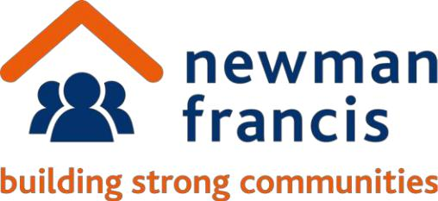
Stratford, E15 2HU

Tel: 020 8536 1436


Email: administrator@newmanfrancis.org

Web: www.newmanfrancis.org

To all Residents of Trico House February 2022

Dear Resident,

Re: Trico House Remediation and additional works

May we take this opportunity to thank you for your continued patience regarding the works. In our last letter, we informed you of the delays to the cladding remediation works at Great West Quarter and the updated target completion dates for Trico House.

The cladding remediation work is nearing completion, but the additional works to replace the existing carrier boards identified by the Fire engineer, which were unforeseen, have implications to the removal of the scaffolding. These works were discussed and explained in communications sent from A2Dominion in November 2021 and the resident webinar held in December 2021 which you can view here: https://youtu.be/8D5rL1K5z88

We are now able to share the scaffolding removal plan for Trico House, which will follow the sequence below, as depicted in the image.

Striking Sequence - Trico House

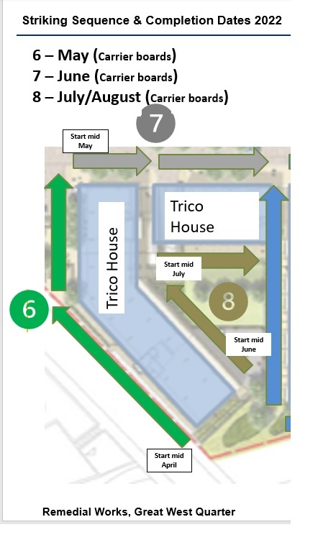

Jessella have divided the works into six sections to help you know what is happening and when. This means the works will proceed section by section. Sections 6, 7 and 8 are dependent on the continued cooperation of residents and completion of the replacement works, of the carrier boards around the windows / patio doors in the affected flats.

Please bear in mind that due to the nature of the works, this will produce some noise and dust, please refer to the Frequently Asked Questions (FAQs) sheet and the Carrier Boards programme of work. Jessella will be using their best endeavours to try and reduce the amount of disruption that the works will cause. Also, please keep in mind these works are subject to favourable weather conditions.

We would like to remind residents to take any precautions you may feel necessary to minimise disruption, including clearing your balcony or terrace to allow the contractors access and minimise the risk of dust and or damage to your belongings.

If you require any further clarification or have any questions about the works, please contact NewmanFrancis on the following number; 07541 916254 or write to us at gwq@newmanfrancis.org. You can also check our webpage to see the latest updates about the project – www.newmanfrancis.org/gwq.

The role of NewmanFrancis relates solely to the work of Jessella. Please continue to contact A2Dominion for other enquiries e.g. repairs reporting and housing management.

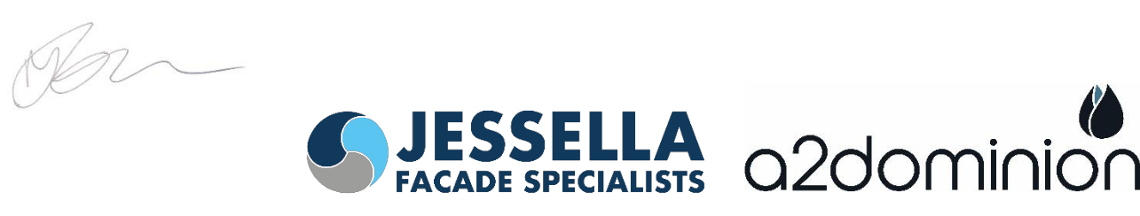Kind Regards

Jacqueline Brown
Resident Liaison Officer

